**Exercise_N1**

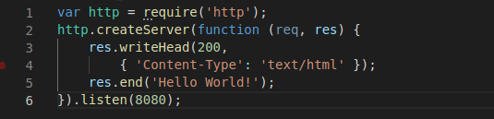

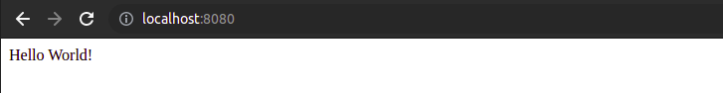

**Exercise_N2**

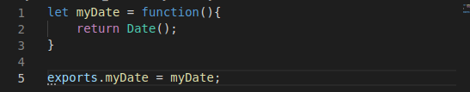

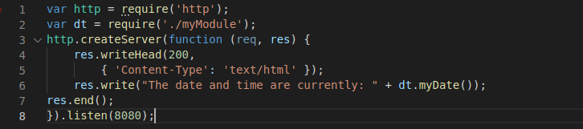

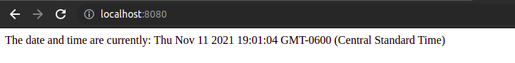

**Exercise_N3**

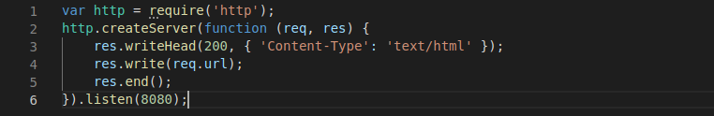

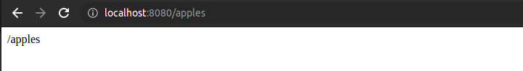

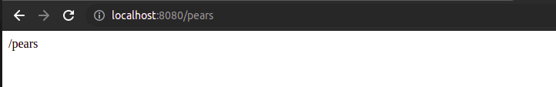

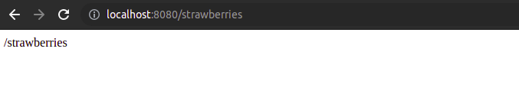

**Exercise_N4**

